* Density =
* A density curve is a **______________________** that describes the **______________________________________________.**

The function that defines this curve is denoted by ________ and it is called the**_____________________.**

* Properties of density curve:

1. f(x) $______$ 0 ( the curve ____________ dip below the horizontal axis).
2. The probability that X falls in an interval is the ________ under ____________________________________ and above _________________________________________.

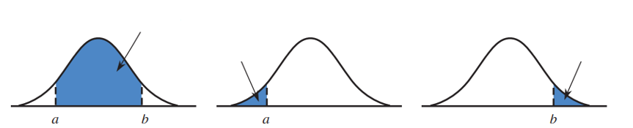

1. The total area under the density curve is

$P\left(a<X≤b\right)=$

 ________
2. ­_____________________

* P(x=a) =

$P\left(a≤X≤b\right)=$

 _____________
* ______________________________________
* Practice:

1. Let X denote the lifetime (in thousands of hours) of a certain type of fan used in diesel engines. The density curve of X is as pictured. Shade the area under the curve corresponding to each of the following

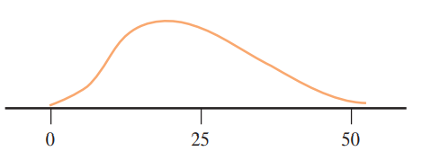

**P(X<30) The probability that the lifetime is at least 25,000 hours**

1. Let X be the amount of time (in minutes) that a particular San Francisco commuter must wait for a BART train. Suppose that the density curve is as pictured (a uniform distribution):
2. 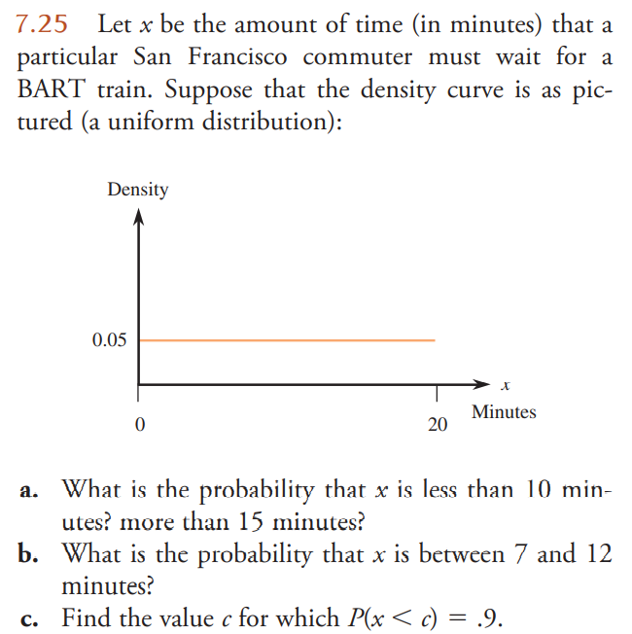What is the probability that X is less than 10 minutes? more than 15 minutes?
3. What is the probability that X is between 7 and 12 minutes?

**c.** Find the value c for which P(X<c) = 0.9

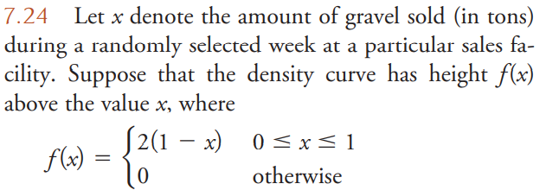

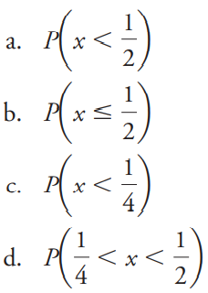

* Mean and Median of Density Curves
* Mean:
* Median:

For a symmetric density curve: mean _______ median

For a right-skewed density curve: mean _______ median

* **Homework：**





1. 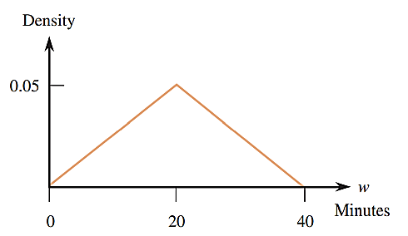Referring to Practice 7.25, let X and Y be waiting times on two independently selected days. Define a new random variable W by W=X+Y, the sum of the two waiting times. It can be shown that the density curve of W is as pictured:
2. Prove that the total probability is equal to 1.
3. What is the probability that W is less than 20?

less than 10?

greater than 30?

1. What is the probability that W is between 10 and 30?